**Date Submitted:**

**Task 00: Execute provided code**

**Youtube Link:**

<https://www.youtube.com/watch?v=nFliIjVSeRg>

**------------------------------------------------------------------------------------**

**Task 01:**

Current period and on-time using provided code:

SysCtlDelay of 2M is equal to 6M CPU Cycles  
6M/40MHz = 0.15s

Period of LED blinking = .3s  
On-Time of LEDs = .15s

Verification:

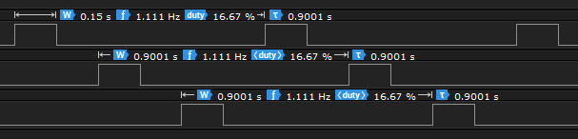

Calculating New Delay:

Using SYSCTL_SYSDIV_10|SYSCTL_USE_PLL|SYSCTL_XTAL_16MHZ|SYSCTL_OSC_MAIN

400MHz/2/10 = 20MHz is the new Clock Frequency

20MHz*0.5s/3 = 3.3M is the new value for SysCtlDelay  
*In the code, SysClockGet() is used instead of raw values

Verification:

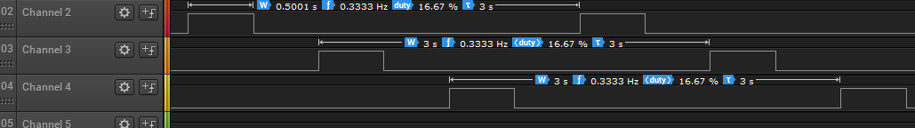

Youtube Link:

<https://www.youtube.com/watch?v=fUpzNutyolo>

**Modified Schematic (if applicable):**

**Modified Code:**

**#include** <stdint.h>

**#include** <stdbool.h>

**#include** "inc/hw_memmap.h"

**#include** "inc/hw_types.h"

**#include** "driverlib/sysctl.h"

**#include** "driverlib/gpio.h"

uint8_t ui8PinData=2;

**int** **main**(**void**)

{

**SysCtlClockSet**(SYSCTL_SYSDIV_10|SYSCTL_USE_PLL|SYSCTL_XTAL_16MHZ|SYSCTL_OSC_MAIN);

**SysCtlPeripheralEnable**(SYSCTL_PERIPH_GPIOF);

**GPIOPinTypeGPIOOutput**(GPIO_PORTF_BASE, GPIO_PIN_1|GPIO_PIN_2|GPIO_PIN_3);

**while**(1)

{

**GPIOPinWrite**(GPIO_PORTF_BASE, GPIO_PIN_1|GPIO_PIN_2|GPIO_PIN_3, ui8PinData);

**SysCtlDelay**(0.5*(**SysCtlClockGet**() / 3));

**GPIOPinWrite**(GPIO_PORTF_BASE, GPIO_PIN_1|GPIO_PIN_2|GPIO_PIN_3, 0x00);

**SysCtlDelay**(0.5*(**SysCtlClockGet**() / 3));

**if**(ui8PinData==8) {ui8PinData=2;} **else** {ui8PinData=ui8PinData*2;}

}

}

**------------------------------------------------------------------------------------**

**Task 02:**

*The provided code was already in BGR sequence, so I changed it to RGB instead.

Youtube Link:

Task 02 A: <https://youtu.be/VEQOMwYCFYo>

Task 02 B: <https://youtu.be/uJpkTpOKcLw>

**Modified Schematic (if applicable):**

**Modified Code:**

**#include** <stdint.h>

**#include** <stdbool.h>

**#include** "inc/hw_memmap.h"

**#include** "inc/hw_types.h"

**#include** "driverlib/sysctl.h"

**#include** "driverlib/gpio.h"

uint8_t ui8PinData=2;

**int** **main**(**void**)

{

**SysCtlClockSet**(SYSCTL_SYSDIV_10|SYSCTL_USE_PLL|SYSCTL_XTAL_16MHZ|SYSCTL_OSC_MAIN);

**SysCtlPeripheralEnable**(SYSCTL_PERIPH_GPIOF);

**GPIOPinTypeGPIOOutput**(GPIO_PORTF_BASE, GPIO_PIN_1|GPIO_PIN_2|GPIO_PIN_3);

**while**(1)

{

**GPIOPinWrite**(GPIO_PORTF_BASE, GPIO_PIN_1|GPIO_PIN_2|GPIO_PIN_3, ui8PinData);

**SysCtlDelay**(0.5*(**SysCtlClockGet**() / 3));

**GPIOPinWrite**(GPIO_PORTF_BASE, GPIO_PIN_1|GPIO_PIN_2|GPIO_PIN_3, 0x00);

**SysCtlDelay**(0.5*(**SysCtlClockGet**() / 3));

**if**(ui8PinData==2){ui8PinData=8;}

**else** **if**(ui8PinData==4){ui8PinData=10;}

**else** **if**(ui8PinData==10){ui8PinData=6;}

**else** **if** (ui8PinData==6){ui8PinData=12;}

**else** **if** (ui8PinData==12){ui8PinData=14;}

**else** **if** (ui8PinData==14){ui8PinData=2;}

**else**{ui8PinData=ui8PinData/2;}

}

}